Azure 70-535 Certification Jump Start

**Day 1** - Tuesday, Jan 16

Radio City (6604) Room - 6th floor

WiFi Password:

Content: https://github.com/guruskill/70-535

Socialize: #70-535 @ITProGuru

|  |  |  |
| --- | --- | --- |
| Time | Speaker | Topic |
| 8:30 AM |  | What to Expect; Q&A; Labs; Simulcast |
| 8:45 AM |  | Welcome remarks |
| 9:00 AM | **Dan Stolts** | Becoming a Cloud Architect & DevOps |
| 10:00 AM | Break/Labs - 15 minutes | |
| 10:15 AM |  | [Design compute infrastructure](https://www.microsoft.com/en-us/learning/exam-70-534.aspx#syllabus-3) |
| 11:15 AM |  | [Networking](https://www.microsoft.com/en-us/learning/exam-70-534.aspx#syllabus-2) |
| 12:15 PM | Labs, Lunch & Networking | |
| 1:00 PM |  | [Secure](https://www.microsoft.com/en-us/learning/exam-70-534.aspx#syllabus-1) Resources |
| 2:15 PM | **Dan Stolts** | Data Implementation |
| 3:30 PM | Hands-On Labs (on-site and take home) | |

**Evaluation Link**:

* Survey Link:

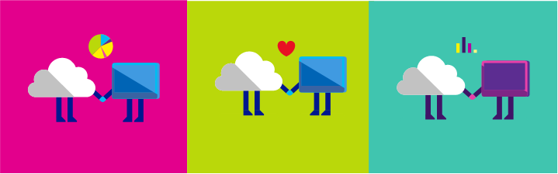

Azure 70-535 Certification Jump Start

**Day 2** - Wednesday, Jan 17

Radio City (6604) Room - 6th floor

WiFi Password:

Content: https://github.com/guruskill/70-535

Socialize: #70-535 @ITProGuru

|  |  |  |
| --- | --- | --- |
| Time | Speaker | Topic |
| 8:30 AM |  | Registration and breakfast |
| 9:00 AM |  | Containers |
| 9:45 AM |  | Platform Services Part 1 |
| 10:45 AM | Break/Labs | |
| 11:15 AM |  | [Platform](https://www.microsoft.com/en-us/learning/exam-70-534.aspx#syllabus-5) Services Part 2 |
| 12:15 PM | Labs, Lunch & Networking | |
| 1:00 PM |  | Operations |
| 2:15 PM | **Break** |  |
| 2:30 PM | **Audience/Tara Webb/Dan Stolts (Microsoft)** | Q&A: How will you use what your have learned? |
| 3:30 PM | Hands-On Labs (on-site and take home) | |

**Evaluation Link**:

* Survey Link: <https://aka.ms/nyc102017>

